OPD REGISTRATION:
When a patient is comes to consulting the doctor in hospital , firstly we have collected the demographic details of the patient like Name, Consulting Doctor, TPA/ Sponsor/ Class, Reference Doctor(if Any) and charges Type (Normal charges, Day or Night Emergency).

- To View the Today's OPD Registration
We can view the total registration done with registration no., consultant and service name for a particular day by selecting the registration date.
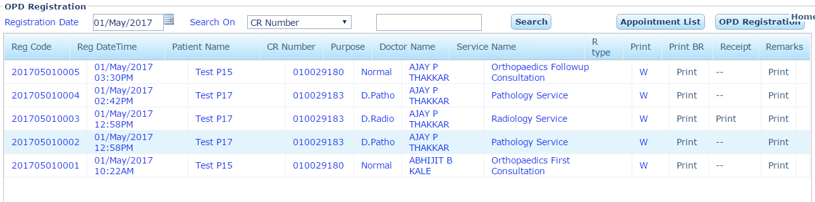
- Registration Date: To select the date for which you have to OPD Registration.
- Search: We can search any patient by their CR Number, Patient Name, UHID No or Company No.
- Appointment List: To View the today appointment of patients for the consultants.
- OPD Registration: To make the OPD Registration of the patient.
- Print: To Print the OPD Case Paper.
- Receipt: To Print the OPD Registration Receipt.
- Print BR: To Print the Bar Code of Pathology / Radiology Investigations.

- OPD Registration Purpose
- Normal: When the Patient comes to consult the doctor in OPD.
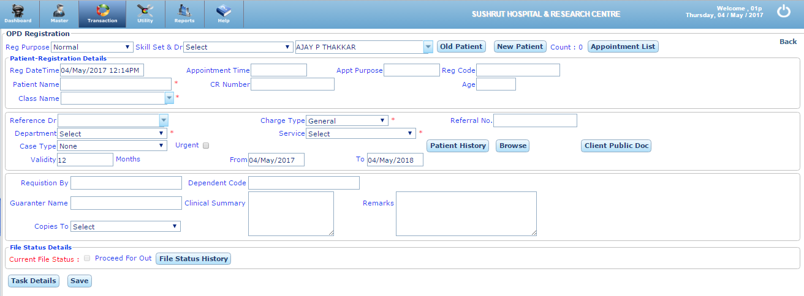
Skill Set & Doctor: When we select the skill, the doctor belong to this skills/ specialty are lists out.

- To Register a New Patient: When a patient visits first time in the hospital we have to register the patient by collecting demographic details.

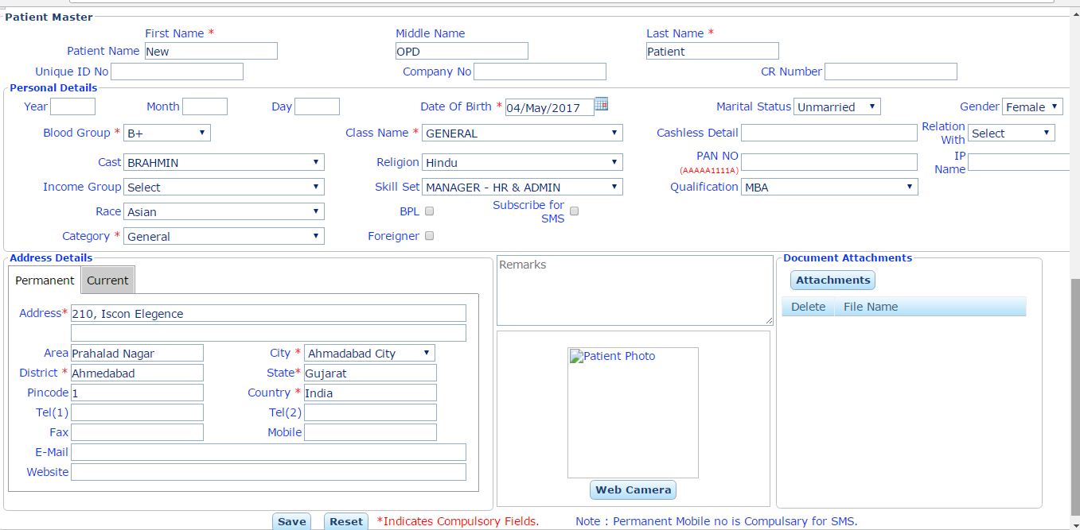
Enter the Demographic Details of the Patient as follows:
- Patient Name: First, MIddle and Last Name
- Age/ Date of Birth
- Marital Status
- Gender
- Class*
- Blood Group
- Religion
- Category *
- Address: Current and Permanent Address with Area, City, District, State Country.
- Mobile No.
- Web Camera*
- Document Attachment*
- Add Ref Doc: When reference doctor is not listed in reference doctor list we can add by click on Add Ref Doc with filling the details of referring doctor.
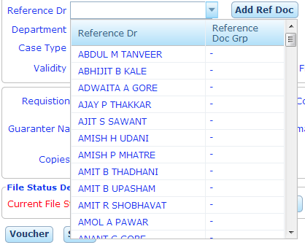
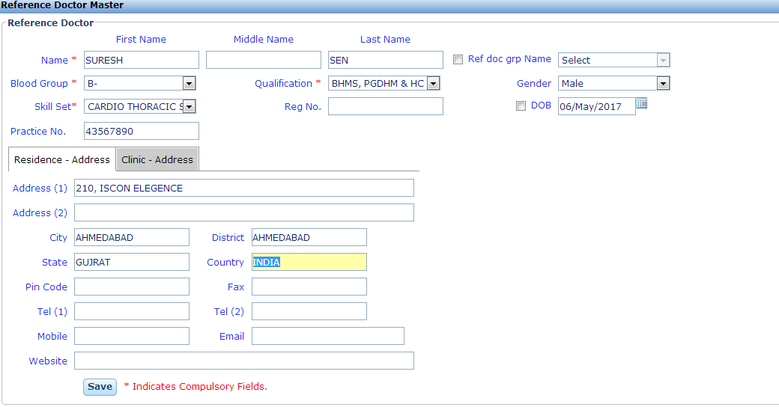
OPD Consultation Charges
When a patient comes to consult the doctor, we have to collect the consultation charges form the patient. We can collect the consultation charges either at the time of OPD registration or after consulting to the doctor.
- Consultation Charges at the Time of Registration
We can collect consultation charges at the time of registration for this we have to select the consultant, charges type and the service either new or follow up service.
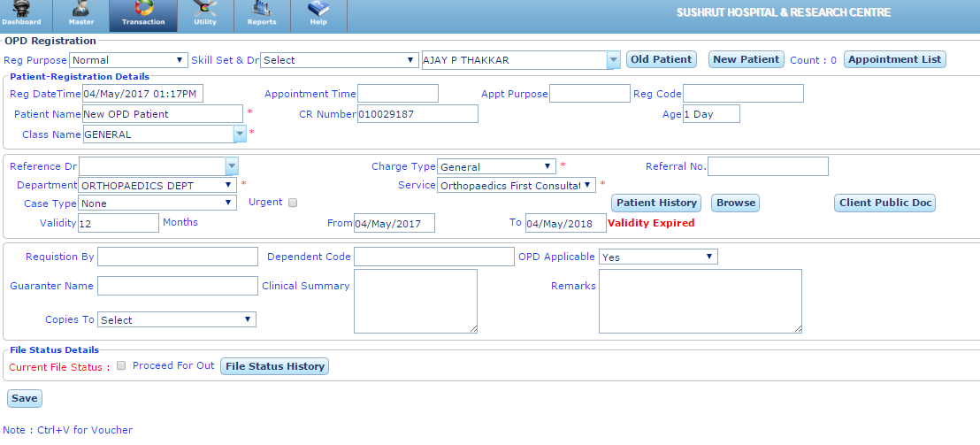
New Patient: To Register an New patient.
Old Patient: To make the consultation bill of already registered Patient. We can find the old patient by CR No. / Patient Name, UHID.
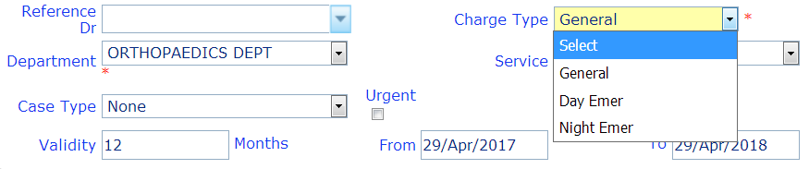
Charges Type: We can take the charges like General, Day or Night Emergency.
Validity: Validity of patient registration with registration date and registration expiry date.
Reference Doctor: We can enter the referring doctor of the Patient if Any.
Case type: Type of the Cases are as follows:
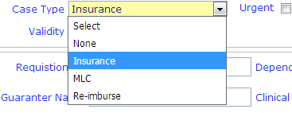
Case type: Type of the Cases are as follows:
Insurance: if the patient have Health Insurance and We can feed the Insurance Company Name Also.
MLC: if the case is MLC (Medico Legal Case) then we have to fill the Police Station.
To create the voucher: click on voucher button or press ctlr+V. We can take the payment via cash, credit, debit, cheque, pay tm etc.
- Make Payment via Cash
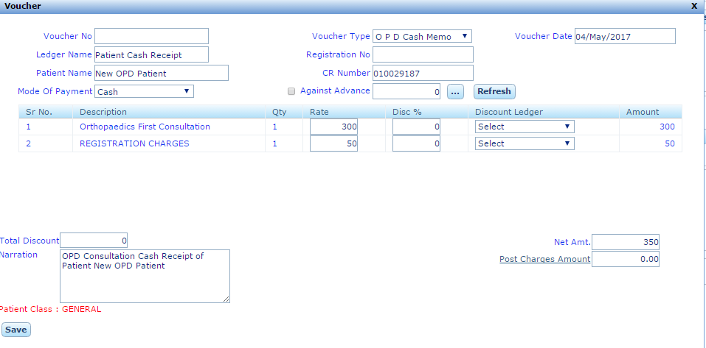

- Make payment via Cheque
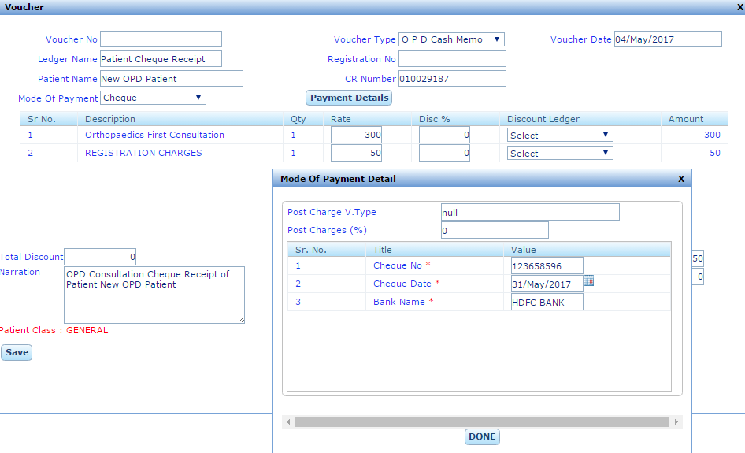
- make payment via smart card
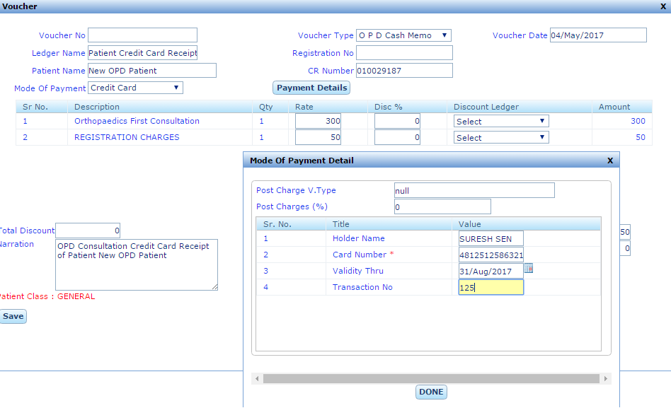
- OPD Consultation via OPD Entry

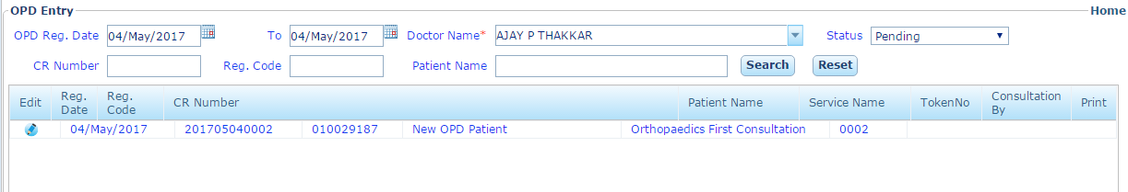
We can view the OPD Entries done on a particular date by selecting the consulting doctor and the status of the entry done or pending. We can also find the OPD Entry by the patient CR No or Patient Name. Now click on OPD Entry to make the visit and click on New Visit.
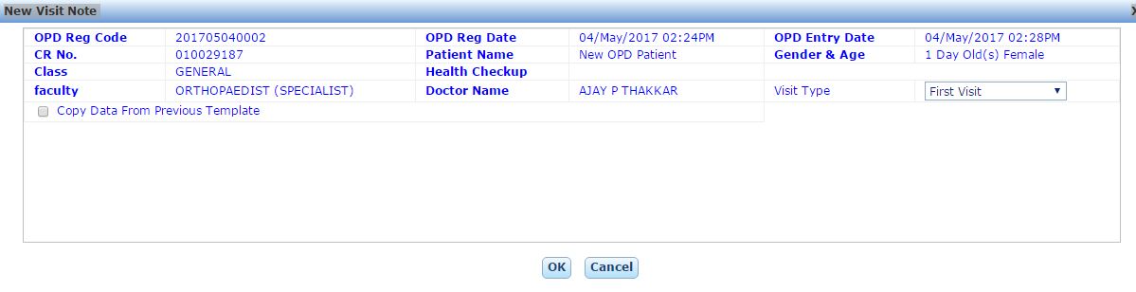
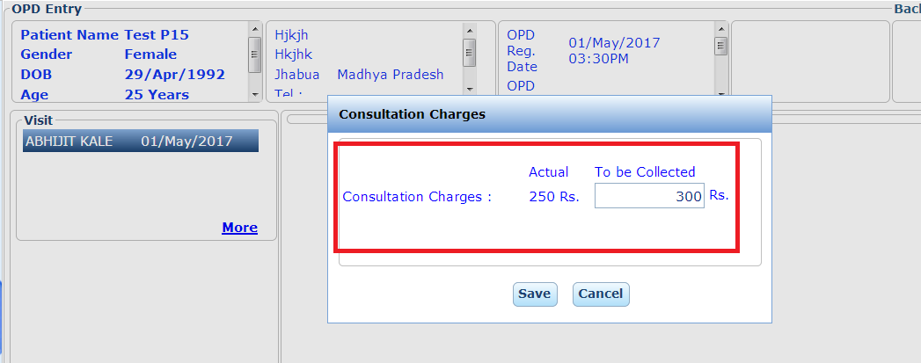
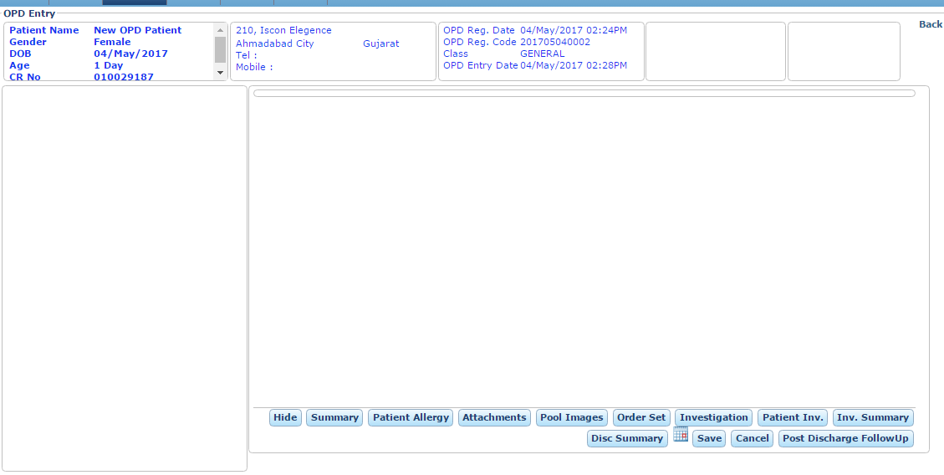
Note: We can view the previous consultation of the patient by the consultant in visit section in OPD Entry.
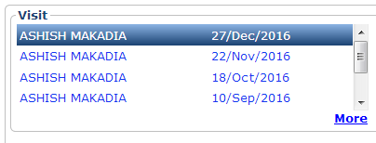
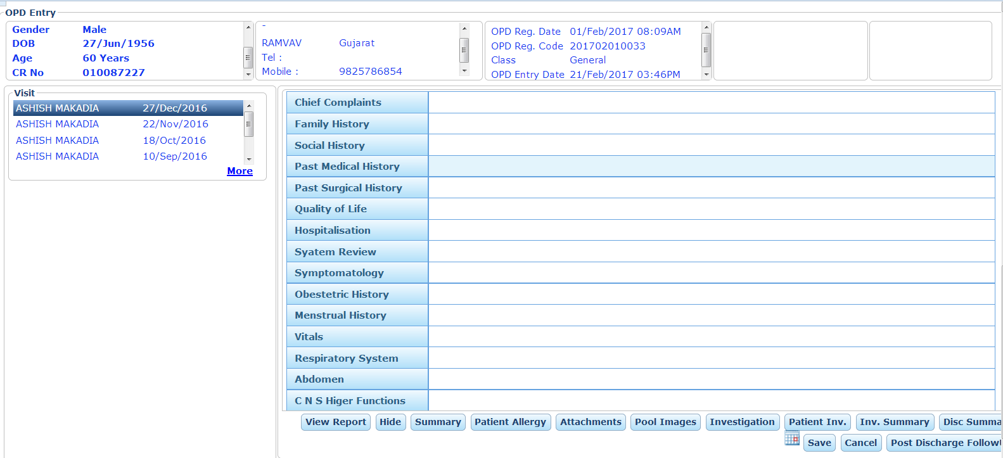

Investigations: Doctor can prescribe the Investigation in OPD Entry
  - Pathology Investigations: Doctor can prescribed the pathology investigations. All the Pathology test and shown in dropdown box.
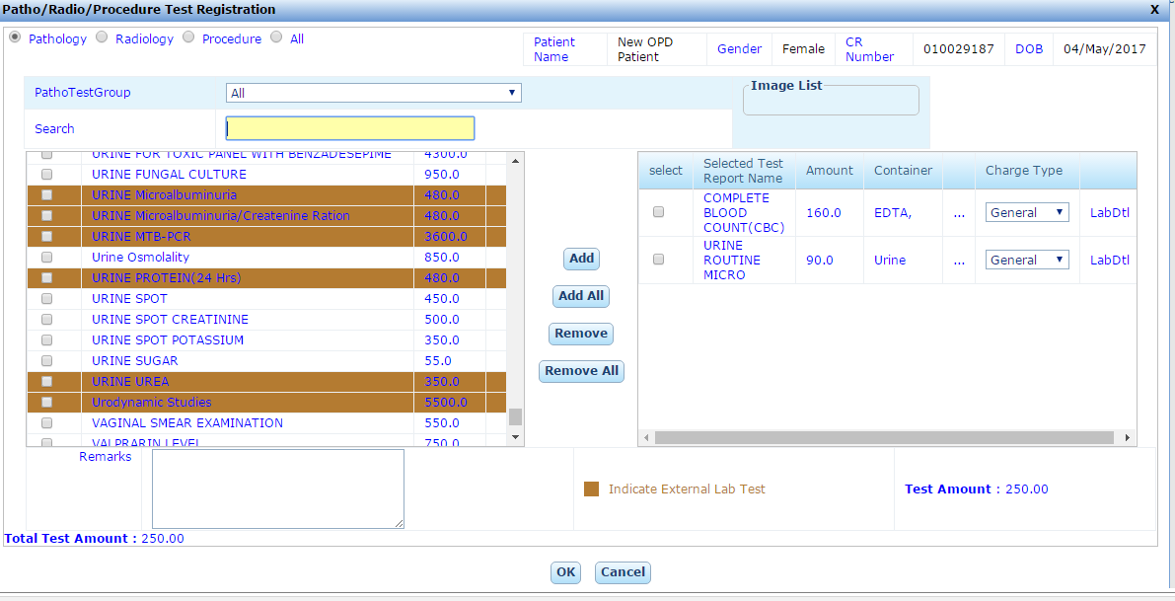
- Pathology Test Group: We can choose the test Group Wise.
- Search: You can search the Test by Test Name in search box.
- Add: This add the checked Test in the service list.
- Add All: All the Test of the Test List.
- Remove: Remove the selected Test.
- Remove All: Remove all the selected Test.

  - Radiology Investigations: Doctor can prescribed the Radiology investigations. All the Radiology test and shown in dropdown box. You can also find the Test Group Wise Like CT Plain/ Contrast, MRI Plain/ Contrast, Sonography, XRAYS.
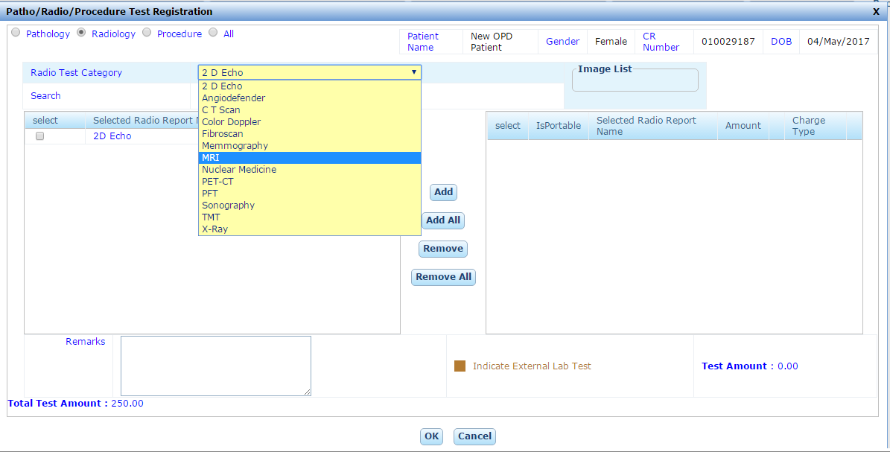
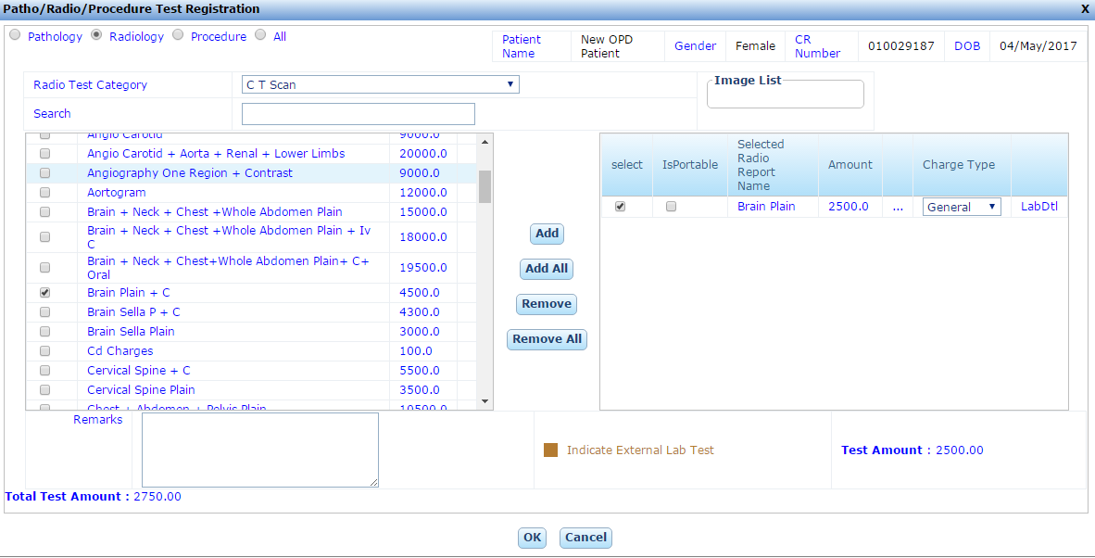

  - Procedures: Doctor can prescribed the Dialysis/ Urology/ Cardiac etc. Procedures.
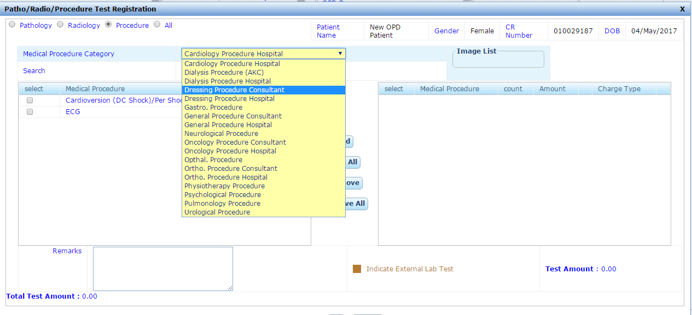
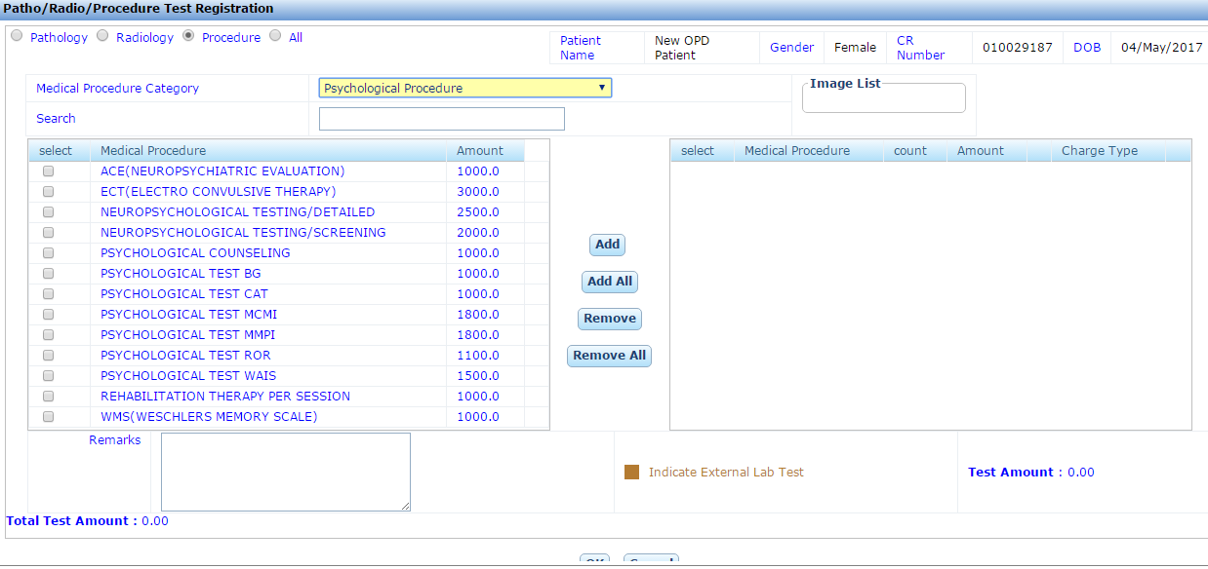

Vaccination Chart: We can schedule the vaccination chart for the child. The vaccination chart is comes automatically from the vaccination Master.
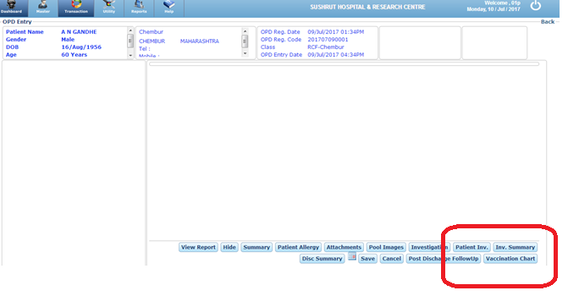
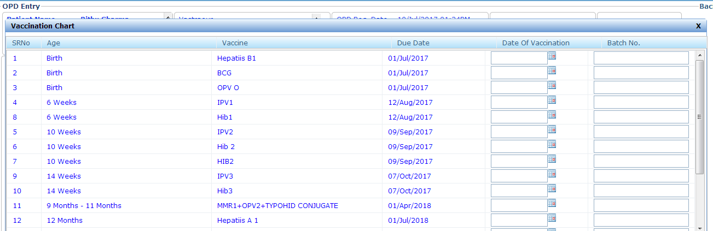
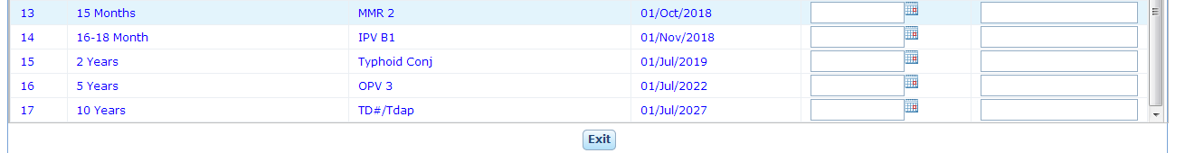
Age: It describe the scheduled age in which vaccine is to be given. Like Birth, 6 weeks, 1 month etc.
Vaccine & Batch: Name of the Vaccine which to be given to the child. And Enter the Batch.
Due Date: It define the on which tentative date vaccine is to be given.
Date of Vaccination: It define the on which actual date vaccine is to be given.
Class
Patient have the different Health Insurance Policy and they belongs from deferent class like General, Cashless, Cashless Reimbursement, Cashless Non Reimbursement and Co-Pay.

- General Class (Cash Patient): When a patient does not belongs to any Health Insurance Policy. He will pay the according to hospital charges either Cash/ Credit/ Debit Card / Cheque.

- Cashless: When a patient belongs form a TPA which provide the cash less facility. For this Patient can have the Referral Letter from their TPA. Patient can't pay any money for this their TPA is responsible for payment. Note: When the Background is green it indicates the cashless class.
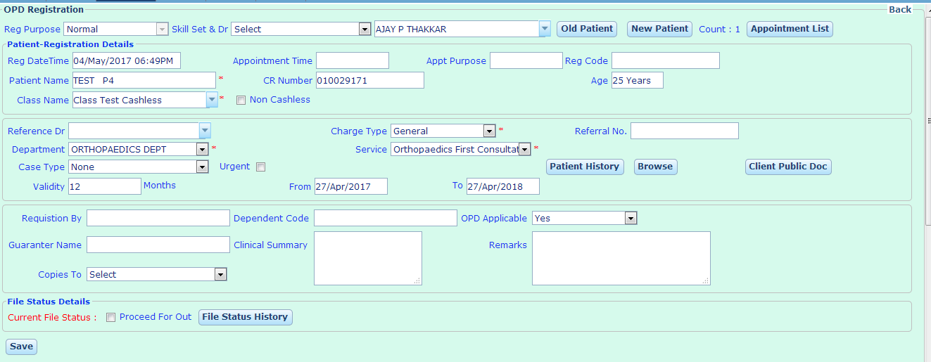
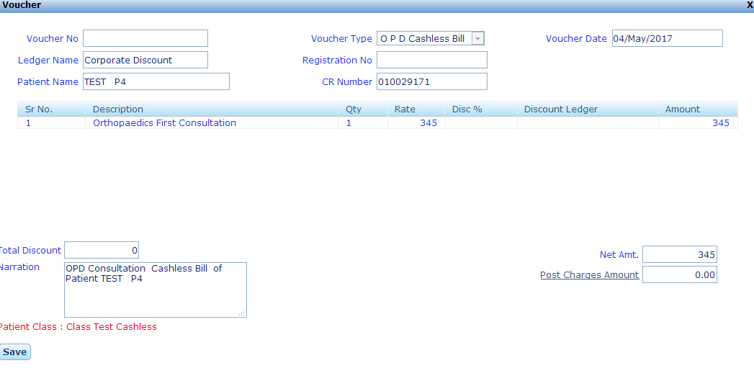
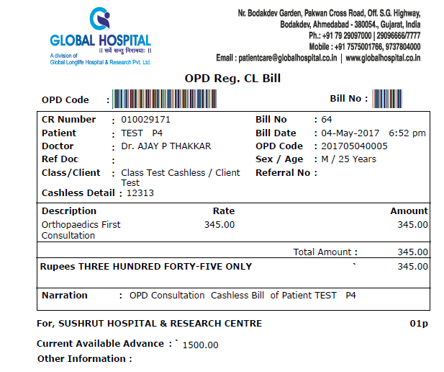

- Cashless Reimbursement: For this type of class, Patient pay the amount at the time of billing and they can reimburse the bills form their respective Company, Organization or Insurance Company.
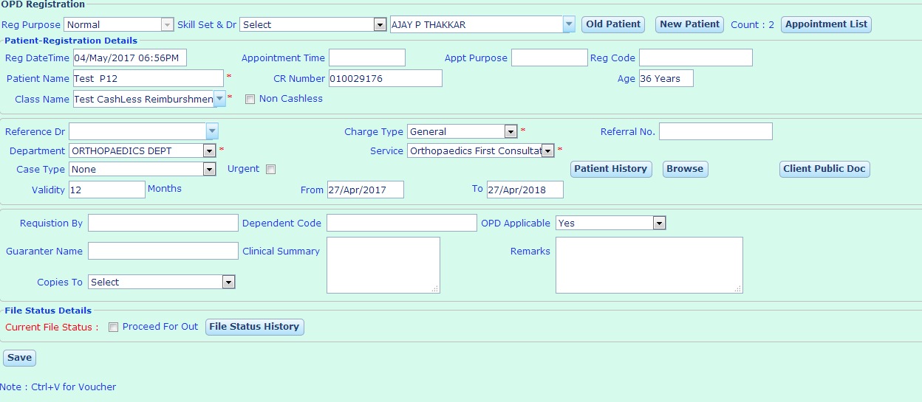
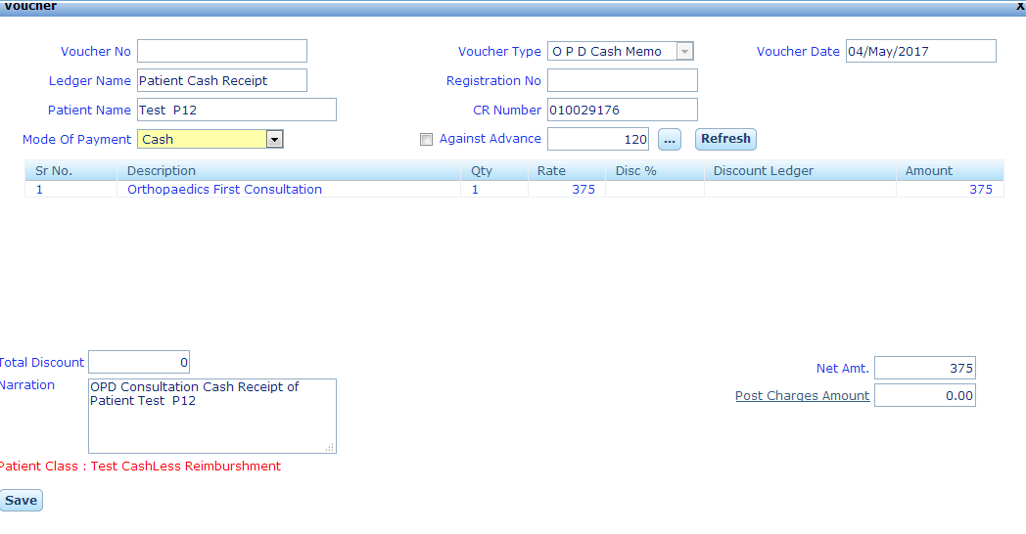
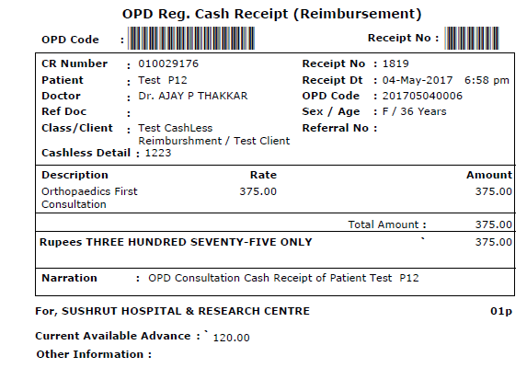

- Cashless Non Reimbursement: There are some services that are not reimbursed by the TPA for that patient will pay the bill and the bill was not reimbursed by the TPA.
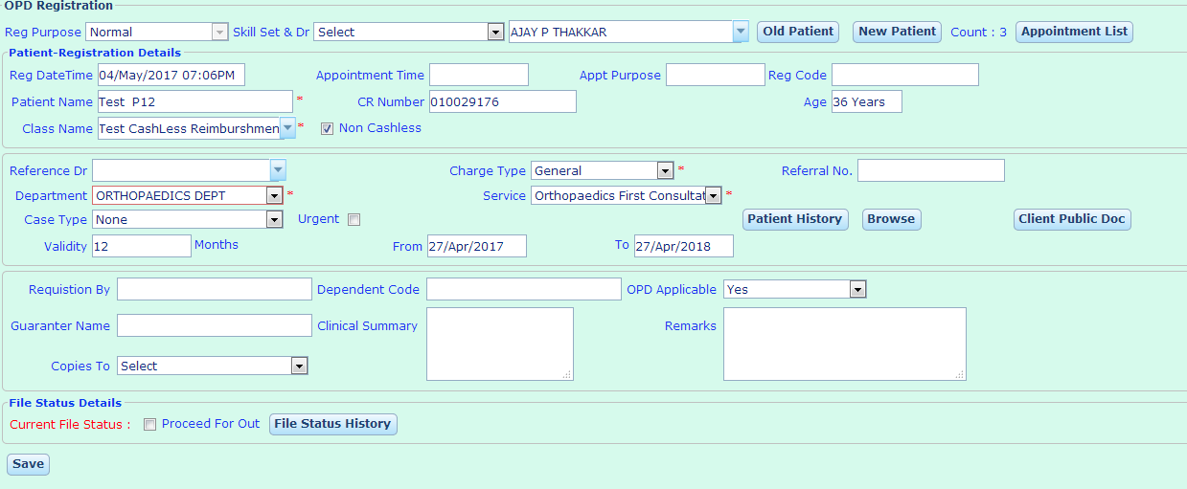
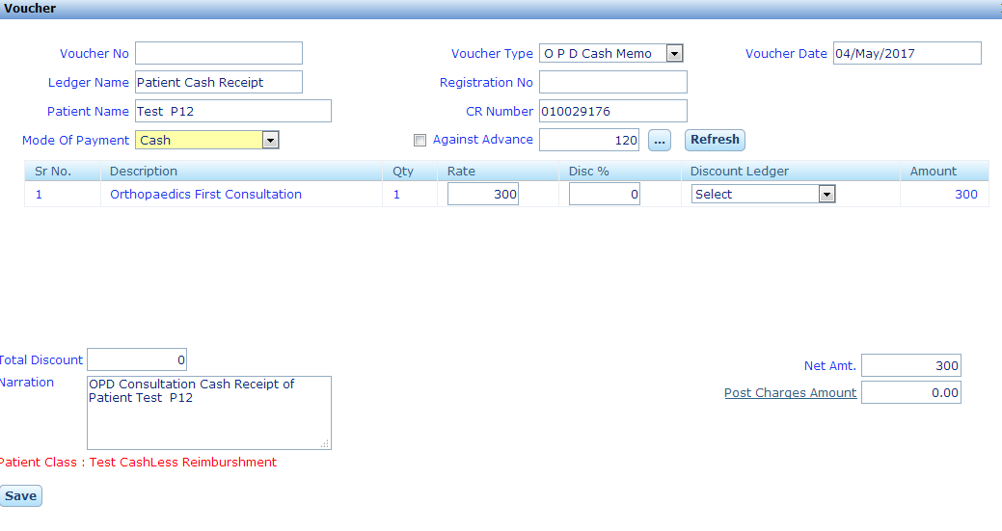
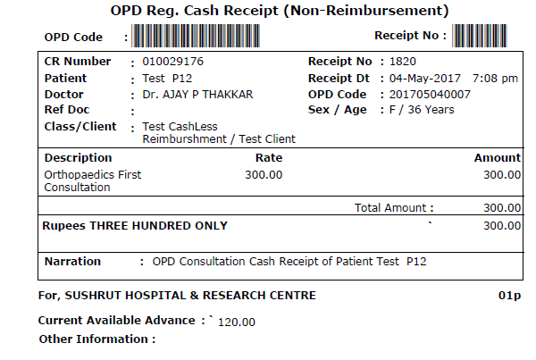
- Co-pay: When the patient belong for the Co-pay Class, the Bill will be paid by both the party’s patient and the TPA as per the ratio in the policy like 50:50, 60:40 or 70:30.
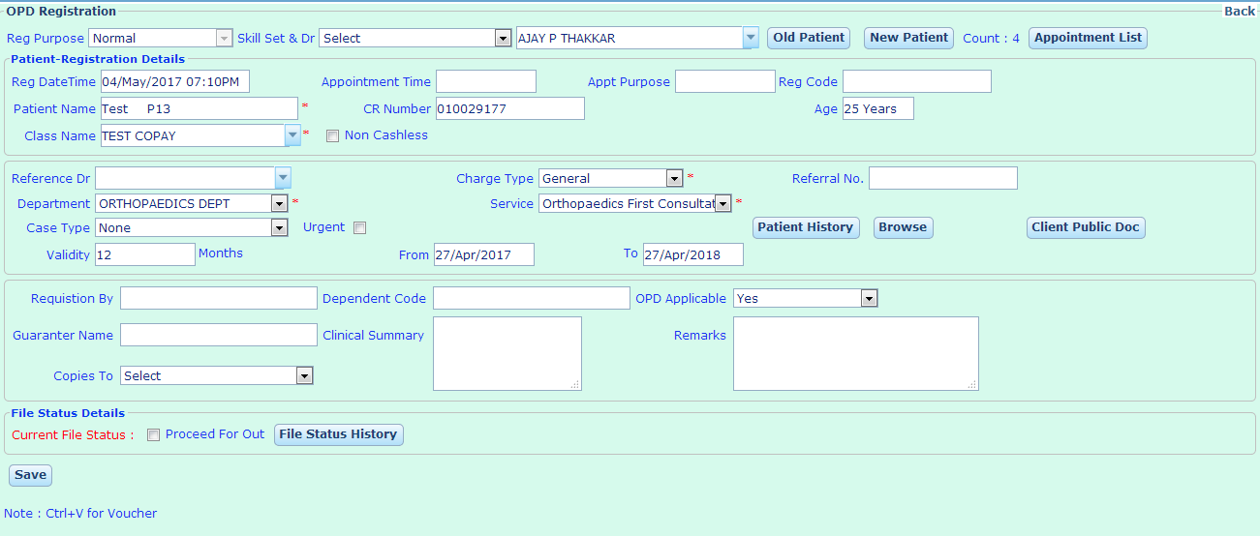
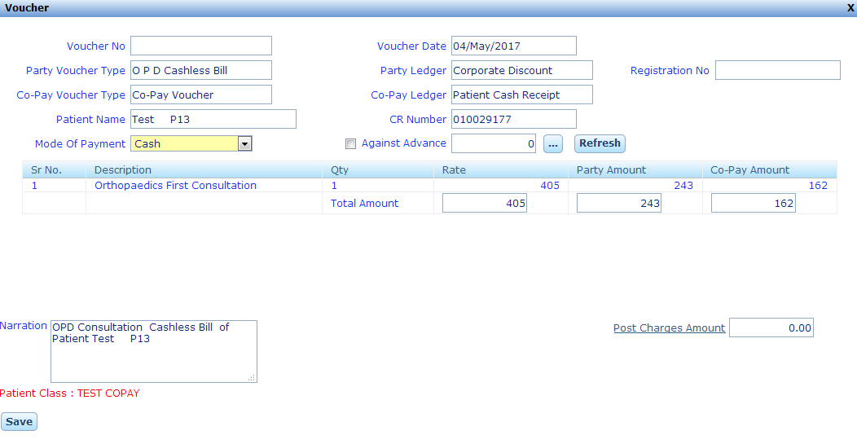
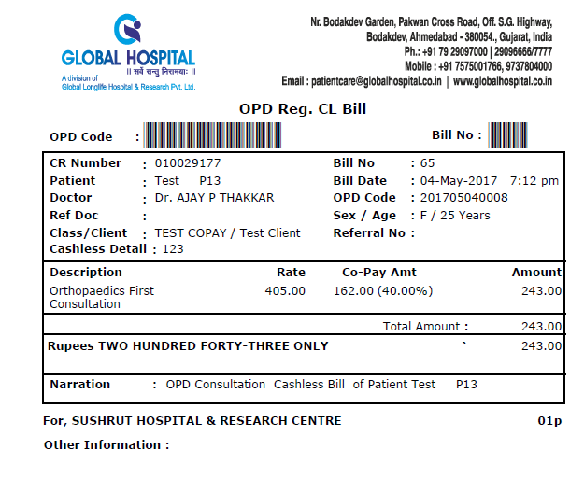
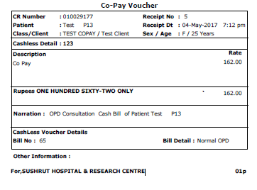

- Direct: When the patient comes to doing the investigation or procedures.

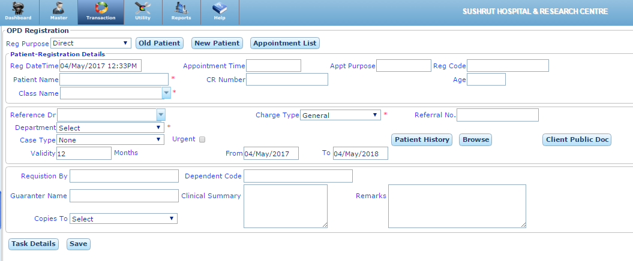
New Patient: To Register an New patient.
Old Patient: To make the consultation bill of already registered Patient. We can find the old patient by CR No. / Patient Name, UHID.
After the selection of the patient either New Patient or Old Patient, the following window is open:
Charges Type: We can take General, Day Emergency or night Emergency.
Reference Doctor: Selection of Referring Doctor is mandatory for the Direct Patient.
Add Ref Doc: If the Reference Doctor is not listed, we can add the New Referring Doctor.
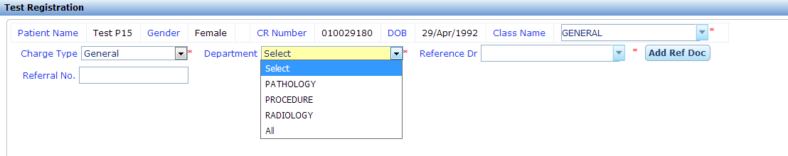

Department: We can Chose the Pathology / Radiology Investigation and Procedures:
- Pathology: When we choose the Pathology in Department all the Investigation of the Pathology are list out we can chose the Investigation that we have to tests.
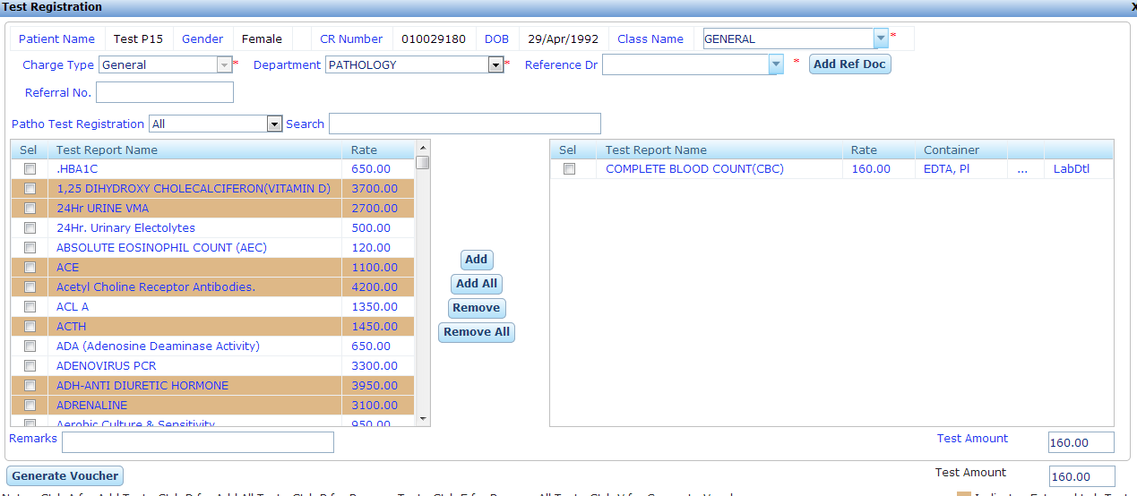
- Radiology: When we choose the Radiology in Department all the Investigation of the Radiology are list out we can chose the Investigation that we have to tests.
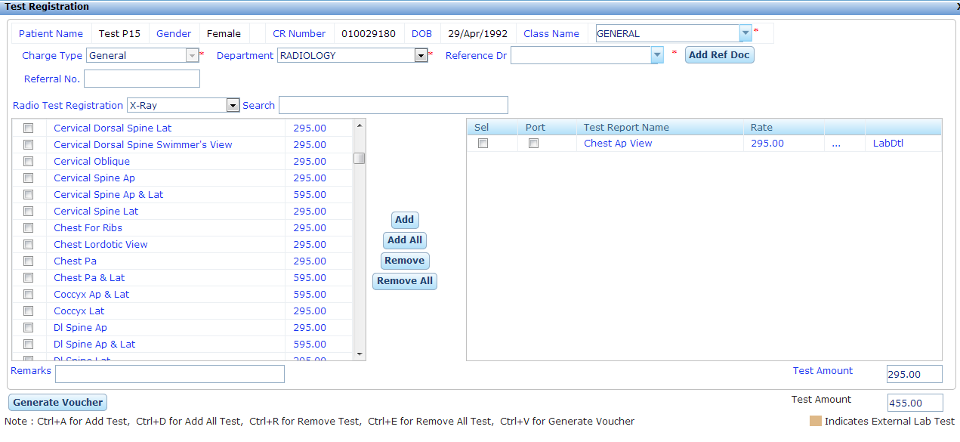

- Procedures: When we choose the Procedure in Department all procedures are list out we can chose the Investigation that we have to tests.
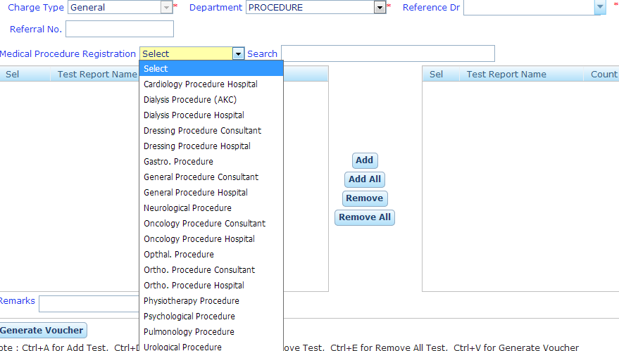

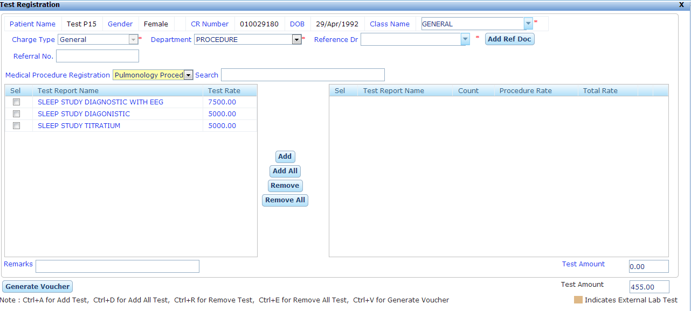

- All: When we choose the All the Department all the Investigation of Radiology and Procedures are list out and we can select the Investigation or procedures that we have to perform.
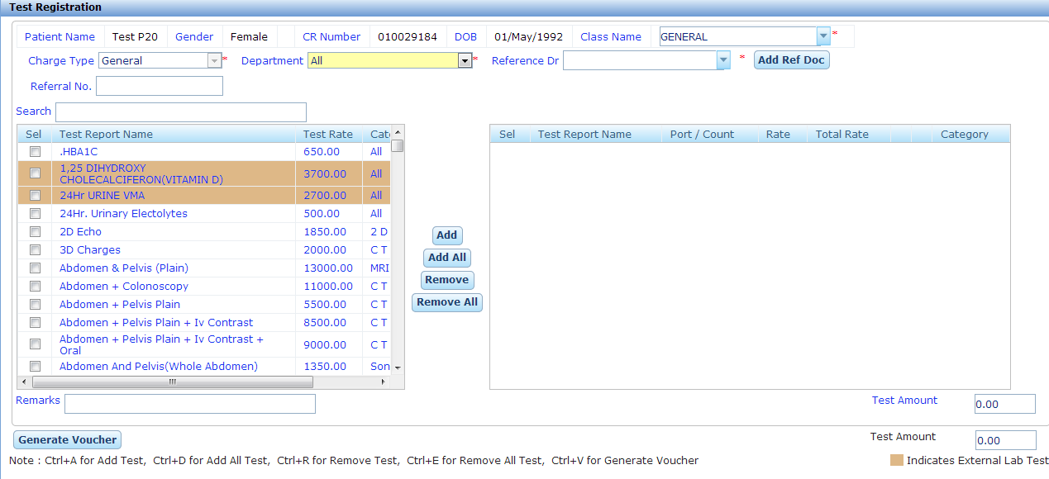
After the Selection of the Investigation/ Procedures, We have to generates the voucher and can make the payment via cash, Debit/ Credit Card or cheque.
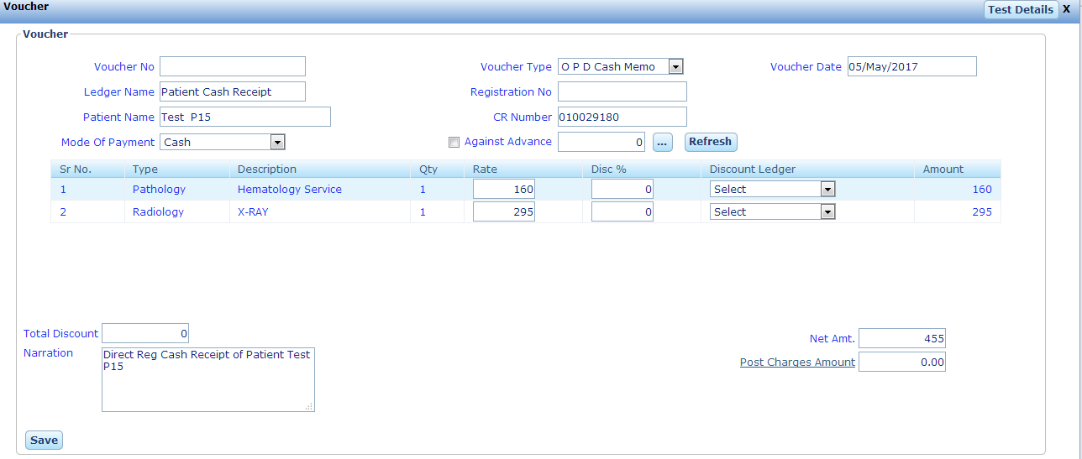

Health Check Up
When patient come to hospital for avail the health check either hospital checkups or TPA Health check Ups.

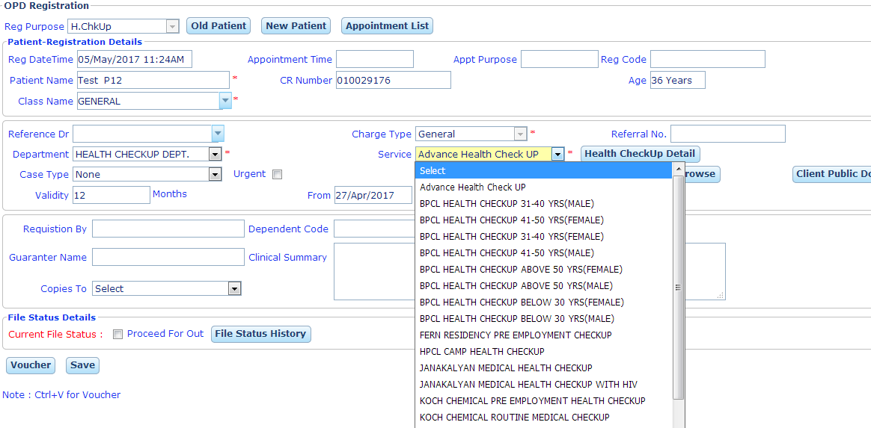
New Patient: To Register a New patient.
Old Patient: To make the consultation bill of already registered Patient. We can find the old patient by CR No. / Patient Name, UHID.
Charges Type: We can take General, Day Emergency or night Emergency.
Reference Doctor: Selection of Referring Doctor is mandatory for the Direct Patient.
Service: All the Health Packages are list out when we choose the "Health Check Up" in Reg. Purpose.
Health Check Details: When we click on the Health Check up Details All the Services provided with the Health Package.
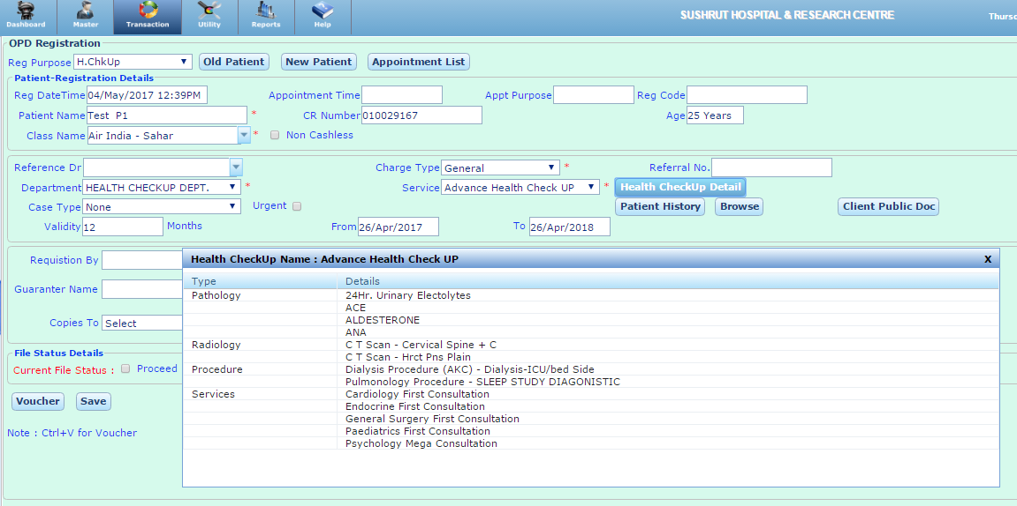
Generate Voucher: Make the payment by creating voucher as Cash, Debit / Credit Card or cheque.
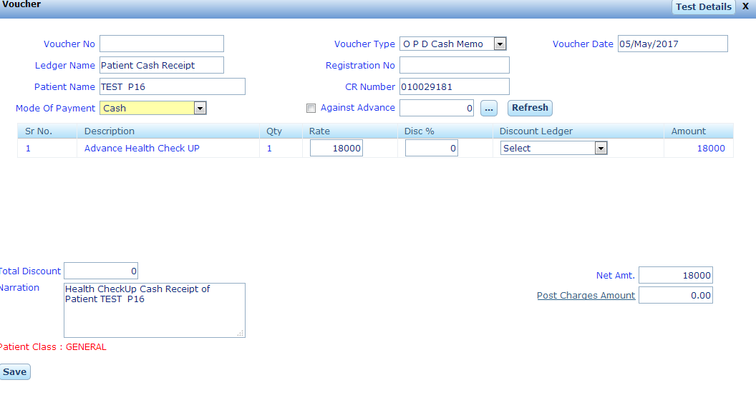
Test Details: While generating we can view the List of Service under health package.
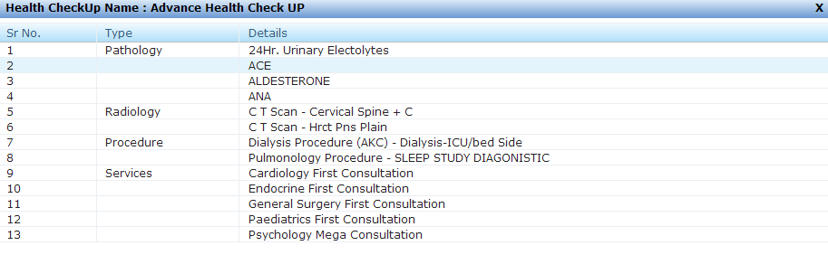
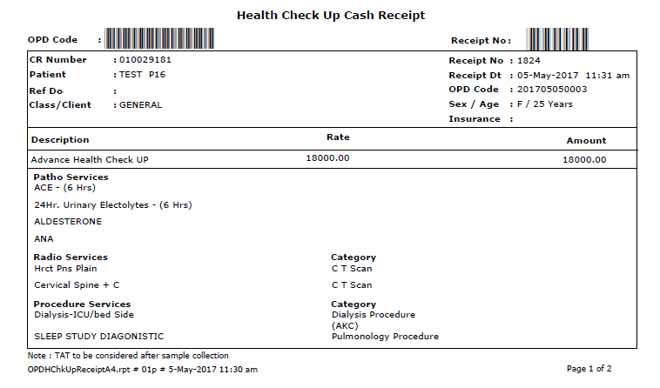

Free Follow-up Services
- Create the service through service master with check enable of free follow-up service.
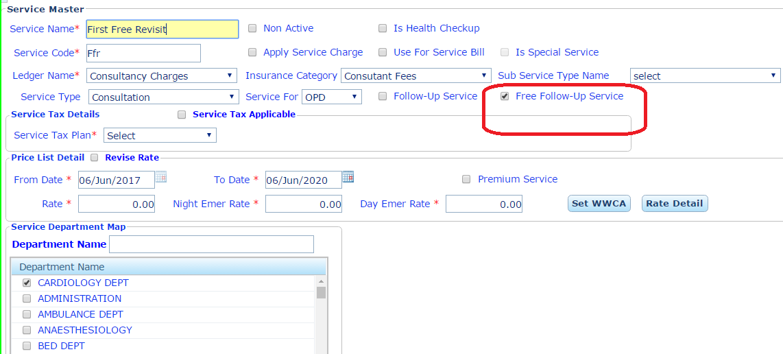
- Set the validity for free follow-up services in “Skill Set Wise OPD Visit Validity”
We can set the validity for the follow up & free follow up service according to the skills/ specialty wise for OPD Visits.

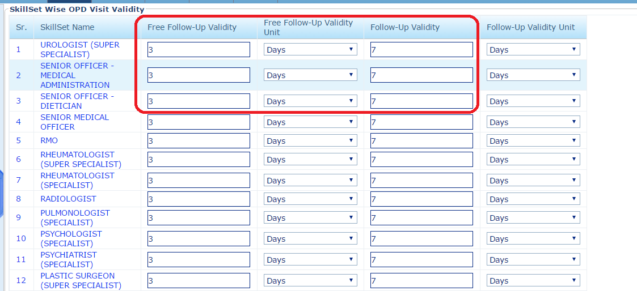
- Make the OPD registration within the free follow-up days.
Note: When we make the OPD Registration within the free follow-up days of same specialty then free follow-up service automatically comes in service name.
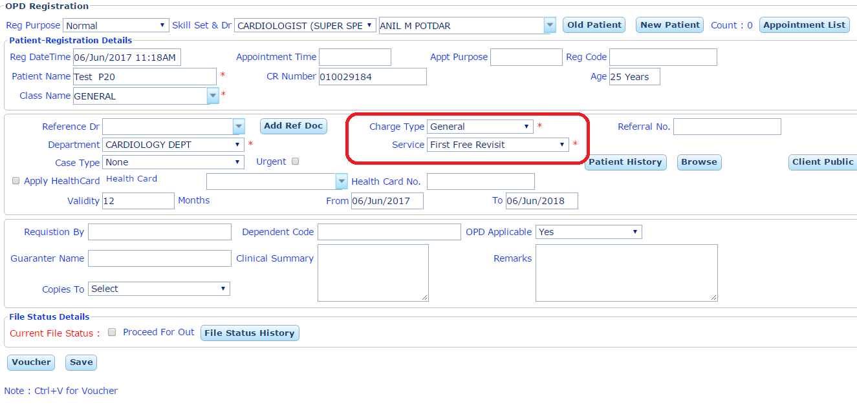
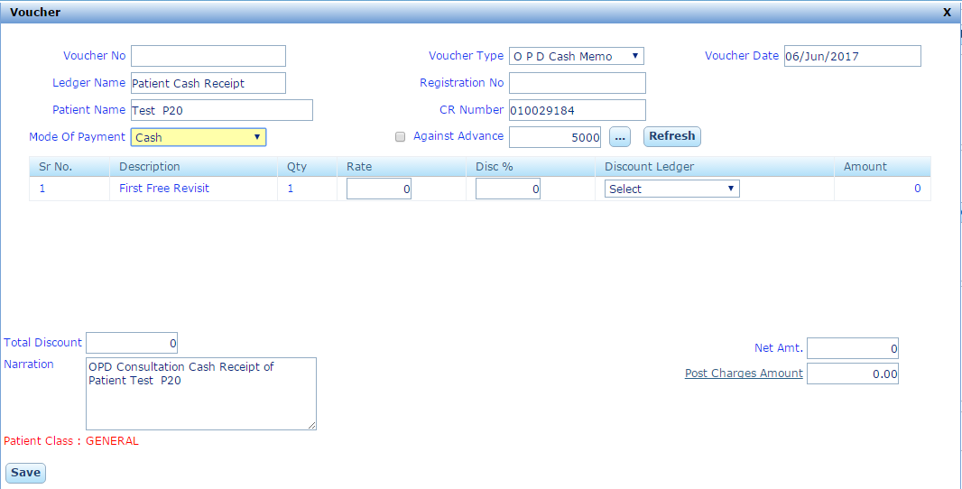

Follow-up Services
- Create the service through service master with check enable of follow-up service.
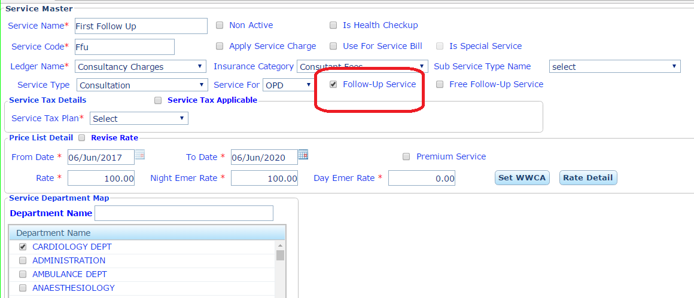
- Set the validity for free follow-up services in “Skill Set Wise OPD Visit Validity”
We can set the validity for the follow up & free follow up service according to the skills/ specialty wise for OPD Visits.

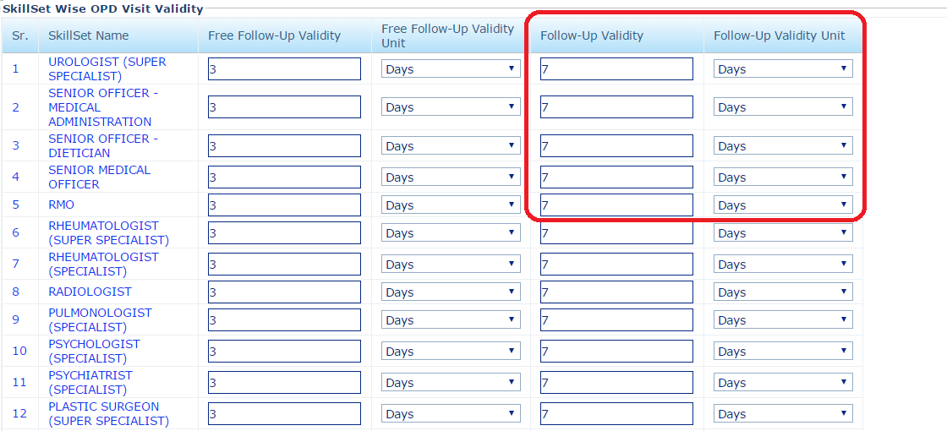
- Make the OPD registration within the free follow-up days.
Note: When we make the OPD Registration within the free follow-up days of same specialty then free follow-up service automatically comes in service name.
